MAG LEVEL 0 FLOOR (1)
Statics | 1. ® © Front Support | 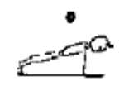
  - Jump legs back to front support (Hold 2 seconds)
 | 2. ® © Rear Support | 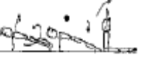
  - Roll over to rear support (Hold 2 seconds). Sit down
 | 3. ® © Shoulder Stand | 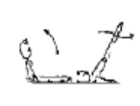
  - Roll backwards to shoulder stand.
Fwd Roll  (for front salto) | 1. Rock n rolls to stand | 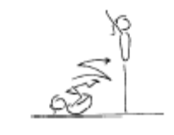 | - knees together, toes pointed  - ability to generate a smooth rocking action alone  - hands on the front of the shins, below the kneecaps  - head tucked in, with chin on chest
 | 2. ®© Fwd Roll | 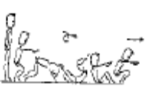
  - From stand, forward roll with bent arms and bent legs to squat, place hands on floor.
Handstand (for walkover, handspring and flic flac) | 1. Angry Cat/Happy Cat position – hold 25 secs
 | 2. Angry cat on floor, turn toes under and straighten legs – keep chest in – back rounded – hold 25 secs
 | 3. Angry cat on a box – hold 25 secs
 | 4. Angry cat on a box, turn toes under and straighten legs – keep chest in – back rounded – hold 25 secs
Cartwheel / Roundoff | 1. F1-4.3 With hands on a raised surface, perform a cartwheel over and back
 | 2. Angry cat position – rocking from hand to hand
 | 3. F2-3.1 Side cartwheel to side handstand position, the coach checks the posture and alignment | 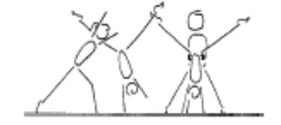 | - keep shoulders and hips square  - lunge into the side handstand  - head neutral  - maintain good body tension and alignment
 | 4. Cartwheel using a large ‘chalk-drawn’ circle
 | 5. F1-4.4 Cartwheel through hoops, stretch the hoops out to encourage the cartwheel to be performed in a straight line | 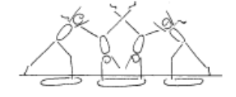 | - maintain good body tension and alignment  - pass through a plie into and out of the skill  - hands parallel, straight arms  - head neutral  - small straddle  - keep arms by ears all through the skill
 | 6. Cartwheel from a raised surface (bench or box) to the ground

MAG LEVEL 0 FLOOR (2)
Backward Roll (for back salto) | 1. F2-4.1 Have the gymnast lie on their back on a supersoft mat, their head is just off the edge, the gymnast places their hands on the floor and performs a backward roll. Once this is mastered they can start from a tuck sit on the supersoft mat | 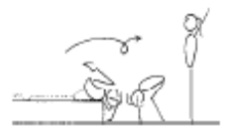 | - confidence and understanding  - legs together  - land on feet and stand  - use hands effectively
 | 2. F2-4.3 Backward roll down an incline – can vary the start and finish positions
Leaps/Jumps | 1. ® © Straight Jump | 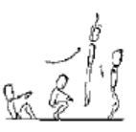
  - Roll forwards to straight jump
FWO, BWO & Tic Toc | 1. F2-5.1 Stand in front of a wall, perform back arch to contact hands on the wall and return to stand | 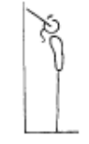 | - keep hips in line with feet  - stretch up first then open shoulders to initiate the back arch  - keep gluteal muscles tight  - maintain good body tension and alignment
 | 2. Shoulder stretch with hands on raised surface – shoulders towards ground – no coach pressure

MAG LEVEL 0 POMMEL (1)
Front Support & Straddle Swings | ® © Front Support, 2 x Push ups | 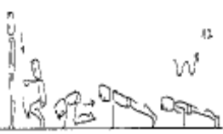
  - From stand, squat down. Place hands on floor jump to front support position
  - Execute 2 Push-ups
 | ®© Rear Support, Front Support | 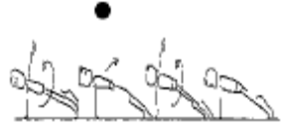
  - Turn over to rear support and show position for 2 seconds.
  - Turn over (continuing in the same direction) to front support.
 | ®© 2 x Push ups in front support | 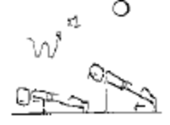
  - 2 push-ups, momentary front support
 | ®© Jump to Squat, Stand | 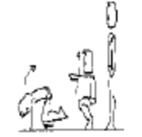
  - Jump to Squat - Stand

MAG LEVEL 0 RINGS (1)
Hangs | ®© Tuck Hang | 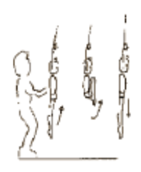
  - Coach lifts gymnast to long hang
  - Lift to momentary tucked long hang. Stretch to long hang
Swings | ®© Swing x 2 | 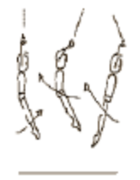
  - Lift legs forwards
  - Swing legs backward
Dismounts | ®© Dismount on back swing | 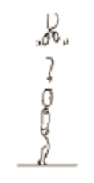
  - On second backward swing, release and dismount to stand

MAG LEVEL 0 P BARS (1)
Supports | ®© Straight Body Support, tuck support | 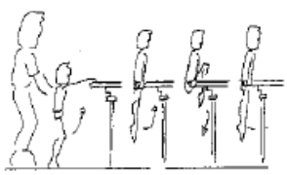
  - Coach lift gymnast to straight body support position on the end of the bars.
  - Lift to tucked support (momentary) (knees above waist)
  - Lower with control to straight body support
Swings | ®© Straight body support swing fwd & bwd | 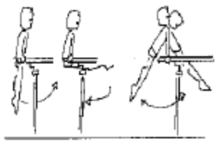
  - Lift legs forward, open hips, swing backward (beat swings)
  - Swing forward and backward
Dismounts | ®© Push off bwds to land | 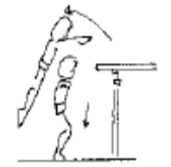
  - On second back swing, push off backwards to landing position, stand

MAG LEVEL 0 HORIZONTAL BAR (1)
Front Support /Casts | 1. Shrugs | 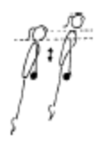 | - straight arms throughout the jump to front support  - chest rounded
 | 2. Jump to front support, push away and return to the bar (cast to clear the bar)
 | 3. ®© Cast off dismount | 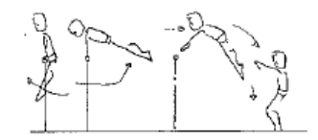
  - With both hands in top grip, pull over the bar to support.
  - It is allowable to step off box or raised surface or use coach assistance if required)
Fwd Roll Dismount | 1. B2-1.1 Tuck leg lifts on wedge x 5 | 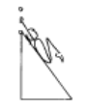 | - bring knees to chest  - maintain good body tension and alignment
 | 2. Spotted Roll fwd on bar to L hang
Pullover | 1. ®© Hands in top grip – pullover (coach assisted if required | 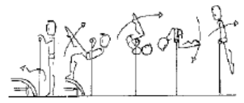
  - Cast off to dismount to stand facing the bar

MAG LEVEL 0 VAULT (1)
Landing | 1. Jump from a box to safe landing position (SLP) on floor
Bounce /Spring | 1. © V1-1 5 x bounces on a board
 | 2. V1-5 Springing circuit – 8 low objects | 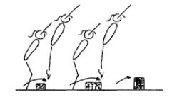 | - maintain good body tension and alignment  - continuous bouncing, no pauses or stops  - easy clearance of the objects
 | 3. V1-4.2 Long Rope Skipping
 | 3. GF3.7 6 x hopping steps on each leg
 | 4. V1-4 5 skips with a skipping rope
Running | 1. V2-3.1 Stand swing arms bent 90’ | 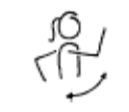 | - bent arms - arms do not drop, or straighten out  - alignment - arms do not swing across body or out to the side  - arms have 90’ bend, lift to eye level and swing back to body line
 | 2. fast run over beat board- consistent speed and stride
 | 3. V2-3.2 From stand – march lifting knees and using arms | 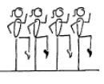 | - lift knees  - toes pointed  - arms have a 90’ bend, lift to eye level and swing back to body line
 | 4. Running drill – arm swing – using 1 knee lift while swinging both arms
 | 5. Running drill – holding foam – knees hitting foam
Hurdles | 1. Step hurdle to spring on floor – arms down when feet land
Straight Jump Vault | 1. ®© Run hurdle 2 feet take off from BB - straight jump to land on 30cm mat | 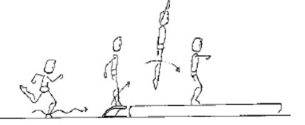
  - Run, hurdle, 2 feet take off to straight jump, arms stretched above head in flight, between horizontal and 45° on landing. (Feet knee high in jump) (Approximately 5 metres run-up)
Catsprings -Handspring Vault | 1. V2-2.3 Wheelbarrow walking – hold gymnast above the knee | 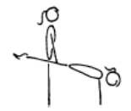 | - rounded back  - hips under & arms straight  - head neutral
Dive Roll / Front Salto | 1. From a run, straight jump onto 60cm mat with straight legs and chest snap

